**HAIR CARE IN VIETNAM**

# VIETNAMESE MARKET AT A GLANCE

Vietnam’s total population was 95.5 million in 2017, an increase of 15.3 million since 2000. The country's median age has been steadily rising over time. It was 31.2 years in 2017 and it will reach 37.0 years in 2030. Per capita consumer expenditure has been steadily rising in real terms as the economy has grown. The indicator was estimated to be VND 36,006 thousand (US$1,610) in 2017. It should rise by 2.4% in real terms during 2018. In the period 2018-2030, total consumer expenditure will grow at an average annual rate of 4.6%. It will increase by a cumulative value of 70.6% during that period. Vietnamese consumers still enjoy healthy gains in their disposable income and expenditure, backed by economic growth and rising wages. Marketers of both budget and high-end goods and services will thus find growing opportunities in Vietnam.

The age group 40-44 had the highest average gross income in 2017, while it was also most predominant in the top income band (i.e. those with an annual gross income over S$250,000). This trend is expected to sustain through to 2030, generating demand for premium, luxury goods and services in family-focused categories. Given Vietnam’s youthful demographic, the age groups 15-37 made up the largest share of the country’s total gross income in 2017. Young Vietnamese professionals living in cities are often brand-conscious and prefer quality products, while their rural counterparts can be targeted for mass-market basic, budget goods and services.

Regarding to Internet usage rate, in 2012 only 37% of the population were internet users, but that jumped to 50.5% by 2017 and it is projected to reach 87% by 2030. Similarly, in 2012 only one-quarter of households possessed smartphones but that increased to 53.5% by 2017 and it is projected to reach 94% by 2030. As access to the internet has quickly expanded, consumers’ shopping habits have been increasingly shaped by digital technology. In particular, the popularity of online shopping continues to grow, reflected by value sales of internet retailing increasing by 333% (in real terms) between 2012 and 2017. In addition, the proliferation of smartphones and the launch of new shopping apps in coming years are expected to cement mobile online shopping into the consumer shopping experience. Indeed, value sales of mobile internet retailing are projected to increase by 391% (in real terms) between 2017 and 2030.

There has been growing demand for male grooming products in recent years, reflected by value sales increasing by 74% (in real terms) between 2012 and 2017. The popularity of nearly all product categories, ranging from the basics such as deodorant and shaving products to specialised skin care products, has grown as males, particularly younger, urban working males, increasingly view a clean and smart appearance as an effective way to express vitality and confidence. For the most part, demand is greatest for international brands. Recent scandals regarding high levels of toxic ingredients found in beauty products have driven greater demand for products deemed natural or organic despite their higher prices. According to the news website vov.vn (2017), there was a growing demand for

“organic personal care items such as those for natural hair care, skin care and cosmetic products”. The source emphasized “increasing consumer disposable incomes coupled with changing lifestyles has contributed to the rising demand for chemical-free skin care and hair care products by Vietnamese consumers”.

# INDUSTRY OVERVIEW

In 2017, Vietnamese hair care value sales rise by 8% to reach VND5.5 trillion. Sales of styling agents increase in 2017 thanks to intense competition among key players. The average current unit price slightly increases in 2017 due to the effects of inflation. Pantene by Procter & Gamble Vietnam Ltd leads the category in 2017. Over the forecast period, hair care is predicted to record a value CAGR (Compound Annual Growth Rate) of 1% to reach VND5.8 trillion in 2022.

## Figure 1: Sales of Hair Care (Vietnam)

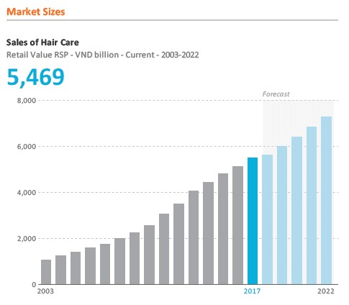

(Source: Euromonitor International, 2018)

Besides the popular shampoo functions such as nourishment, producing silky hair and generating volume, shampoo now has other product functions and ingredients. Key players have launched shampoo that provides new benefits: hair fall control, fights pollution, intensive repair etc. As well as natural ingredients, such as avocado and mint, which have been popular in the last few years, shampoo now contains ingredients such as vitamin E, calcium, keratin and biotin. Over the forecast period, there will be more products focused on repairing and rescuing damaged hair and hair loss; they will be designed to fight pollution and the chemicals used for hair styling, e.g. colourants. Minerals and natural ingredients will also be important as consumers are more aware of the ingredients used to improve their hair conditions.

**COMPETITIVE LANDSCAPE**

# Pantene by Procter & Gamble Vietnam Ltd Leads the Shampoos Category

Pantene remains the biggest brand in Vietnamese shampoo market owing to its consistent brand strategy, strong distribution network provided by Procter & Gamble Vietnam Ltd and product quality that meets consumers’ needs. In 2017, Pantene continually updated its hair control series products with pro vitamin to rescue hair loss. Besides its shampoo, Pantene launched 3-minute conditioners that are intended to prevent hair loss and protect hair against UV and pollution. While other competitors focus on nourishment and silky functions,

Pantene seems to target hair care treatment that protects and repairs damaged hair, which addresses the main concerns of young consumers, especially as they are more aware of the effects of pollution and UV. A consistent marketing strategy is another factor in Pantene leading value sales, as several campaigns have been launched that feature celebrities, not only in Vietnam but in other countries too.

# X-men Is the Most Popular Brand for Men’s Hair Care

In 2017, X-Men led men’s hair care with numerous products from shampoo to styling agents, with versions that were suitable for different people’s styles. In 2017, X-Men launched mainly wax and gel styling agents to compete with Romano, and ran the hairXstyle in 2017 to create awareness of its new product developments. Also, to encourage men to start taking care of their hair, X-Men offered promotions on product packs including shampoo and hair wax, along with travel kits, to let consumers try its entire hair care series.

# CLEAR LEADS ANTI-DANDRUFF HAIR CARE

CLEAR by Unilever Vietnam International Co Ltd is well known for its product-focused strategy of investing mainly in anti-dandruff hair care for both men and women. Unilever Vietnam International aims to retain its leading position in most beauty and personal care categories in Vietnam. Unilever Vietnam International Co Ltd remained the leader in beauty and personal care, with a 27% share of retail value sales in 2016. The company’s most famous beauty and personal care brands include Sunsilk (shampoo); Hazeline (bath gel, facial cream, body lotion); Axe (men’s personal care product), Lifebuoy (soaps & hand sanitizer products); Pond’s (facial care products), Rexona (armpit care products); CLEAR, Dove (shampoos); P/S, Close-up (toothpaste); Vaseline (body lotion); and Lux (bath and shower). Unilever Vietnam International Co Ltd always is known for its dynamic marketing activities and plays a huge role in increasing consumers’ awareness of the benefits of using beauty and personal care products. Consumer behaviour changed over time as a result of its marketing campaigns. For example, in 2016, Unilever held events at many schools in rural areas to improve students’ knowledge of the benefits of brushing teeth and using soap to protect their health. Unilever Vietnam has a very wide distribution network all over Vietnam which includes 150 distributors and 200.000 retailers nationwide.

CLEAR was launched in 1981 and sold under the CLEAR name in most certain global countries. It has two main product types: shampoo and conditioner. Unlike Sunsilk, Dove or Pantene with their various product functions and different ingredients, CLEAR offers only four shampoo types, with mint being the main ingredient advertised, and focuses on antidandruff function. This marketing strategy has brought it success over the years; in 2017 it was the third-biggest brand in shampoos, benefiting from a consistent brand image and from offering products suitable for tropical-weather countries such as Vietnam. Besides this, CLEAR has maintained its competitive advantage in the form of its strong distribution network of store-based retailers and is one of the first brands to start selling online through marketplaces such as Lazada, Tiki and BachHoaXanh. For instance, on Lazada.vn, CLEAR has its Flagship online store with various products at different size, prices and functions. Amongst various competitors, Head & Shoulders by Procter & Gamble is the strongest and most direct competitor with CLEAR in Vietnamese market. This P&G shampoo focuses on anti-dandruff function for both male and female consumers.

According to Unilever Vietnam, CLEAR is the Number 1 shampoo in Vietnam that targets at mainstream consumers who live in urban and suburban areas with low to medium income. The brand mainly focuses on offering updated technology solutions to dandruff and other scalp problems (itch, dryness and grease) - allowing consumers to leave behind any inhibitions and look their flawless best. CLEAR believes that a healthy, nourished scalp is the source of protection against scalp problems. Ordinary shampoos just wash away dandruff superficially, so dandruff comes back again and again. CLEAR is different from other shampoos because it nourishes scalp from within to prevent dandruff from coming back. CLEAR offers a wide range of solutions to both male and female. At Unilever, CLEAR team recognizes that different scalps have different requirements. To address this and other specific needs, CLEAR has developed different tailored dandruff solutions to suit consumer’s individual scalp types. This includes the first ever range of anti-dandruff shampoos formulated specifically for men. CLEAR is also available in conditioners. In terms of innovations, CLEAR’s revolutionary globally patented technology includes customised technology - CLEAR TECH® for both male and female. It removes dandruff, nourishes the scalp and prevents dandruff from returning. As the popularity of men’s grooming products rises, CLEAR continues to improve its products for men and introduce new variants every year. Furthermore, styling agents is another category in demand for men. There are some key players that started to invest in this category earlier in recent years, but 2017 saw intense competition among X-Men, Romano and some other small brands. The most popular type of styling agent is wax, which is able to hold one’s hairstyle the whole day; hair gel is the second most common type and attracts young people but is not as popular as wax. CLEAR is planning to launch its new styling agent, which is a hair wax, called CLX in late 2018. CLX will be introduced to target at same mainstream segment as its shampoo for men. This wax’s price varies depending on its benefits and features. For example, CLX for color hair has the price of 100,000 VND (150 gram) whereas CLX for normal hair is sold at 75,000 VND (150 gram) retail price. At CLEAR’s Flagship Store on Lazada, the retail price for each of its shampoo variants for men is provided as following:

* CLEAR Deep Cleanse: 98,000 VND (370 gram)
* CLEAR Cool Sport Mint: 95,000 VND (370 gram)
* CLEAR Men Hair Fall Defense with Ginseng: 199,000 VND (370 gram)

So far, CLEAR has a quite limited number of choices for men. These limited choices may not be able to satisfy different needs and requirements for men who look for anti-dandruff products with more attractive features. Besides, CLEAR’s packaging is considered boring because of its outdated fashion style, compared to other competitors’ products. Last month, CLEAR Men Hair Fall Defense with Ginseng has just been introduced in all over Vietnam’s large cities and provinces. This new product promises that with its new BIO NUTRIUM 10 and Ginseng Extract, the product will not only address the symptoms of scalp problems but also nourish consumer’s hair from root to tip. This special substance is CLEAR’s secret scalp-care ingredient and is one of their most exciting breakthroughs, a combination of 10 vitamins and mineral nutrients that deeply nourishes the scalp – where it matters most.

CLEAR Men has several major competitors in Vietnamese market, including X-Men and Romano. These competing brands offer different variants and choices for the consumers to choose. X-Men’s shampoo has the price of 95,000 VND (380 gram) for its variant X-Men Active, X-Men Sport, X-Men Fire, X-Men Wood and X-Men Water. In recent months, X-Men has just launched X-Men For Boss Perfumed with the price of 101,000 VND (380 gram) with the focus on long lasting fragrance for men. The other competitor of these two brands is Romano by Wipro Unza Vietnam Corporation. This product also targets at the same segment as the previously mentioned brands. The price of Romano’s product is 88,000 VND for a 380-gram shampoo bottle, applied to all of its variants including Romano Classic, Romano Attitude and Romano Force.

In terms of promotion strategies, CLEAR has done various activities and promotional campaigns in Vietnam. CLEAR is famous for using celebrities to endorse its brand. The list of celebrities includes supermodel Thanh Hang, singer Toc Tien, football player Cristiano Ronaldo or Korean actor Bi Rain. CLEAR airs its TV commercials very frequently on many local and national TV channels in Vietnam. Besides TVC, CLEAR also advertises its products on many newspaper, magazines and online newspapers. Although CLEAR has been in Vietnamese market for many years, not until recent year it introduced its first Facebook Fanpage to connect with its consumers on the social media. CLEAR collaborated with Jana Mobile Tech Company to create a campaign that can attract Vietnamese consumers. CLEAR invited Facebook fans to answer 5 questions about hair and hair problems and asked the consumers to provide their mobile phone number to receive 20,000 VND reward in their mobile phone account. The campaign’s objective is to collect data from 10,000 consumers within 2 weeks. Surprisingly, CLEAR received 20,000 responses from its Facebook fans within 24 hours. More importantly, 95% of the campaign’s respondents fall into their target customer’s age range, which is the group of 15-30 year-old. Furthermore, CLEAR was also able to collect important information and insight which are useful for its product innovation and development in the future. As a result, CLEAR certainly knows how to utilize its social network to increase the brand awareness and brand interaction with its consumers. In recent campaigns on its Facebook Fan page, CLEAR used the image of Vietnam’s Olympic Football team’s players such as the famous goal keeper Bui Tien Dung and goal attacker Cong Phuong to show CLEAR’s support to the football team in Asian Games (known as ASIAD) and to draw the attention from the fans.

***Figure 2: Clear’s social media campaign in 2018, using Vietnam’s Olympic Football team’s players.***

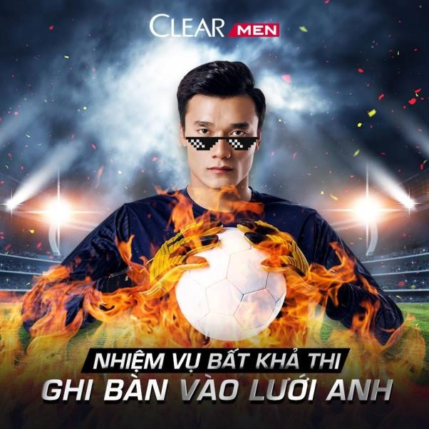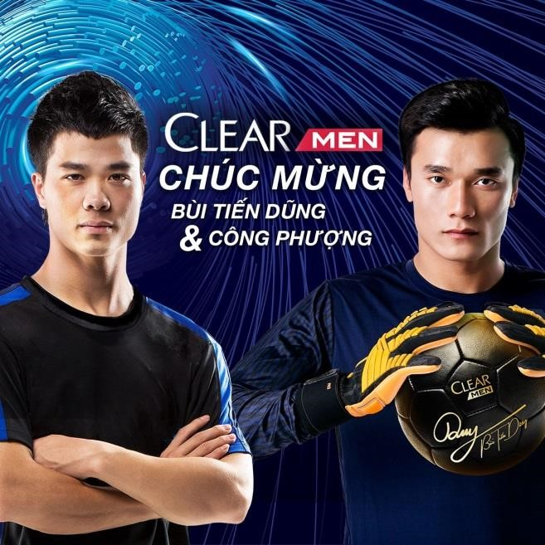

*(Source: CLEAR’s official Facebook Fan Page)*

Due to the increasing competition, CLEAR has recently offered many sales promotional campaigns such as give away free helmets, t-shirts, backpacks and sport handbags if the consumers buy some particular CLEAR products. For examples, if the consumers buy CLEAR Cool Sport Mint 370 gram together with Axe Black 150ml, the total reduced price will be 183,000 VND instead of 206,000 VND for 2 products. Beside, if the consumers buy these 2 products together, they will be given a sporty handbag for free. In addition, CLEAR’s website also provides many tips and knowledge for consumers to have healthy scalp with nutritious diet menus or ‘DOs and DON’Ts’ in taking care of the hair and so forth. In 2015, Guinness Vietnam organization offered the certificates to CLEAR to recognize its record of the ‘longest water slip and slide in Vietnam’ during its campaign “Open the Coolness”. This campaign was launched in many large cities in Vietnam during 2016 to encourage consumers to participate by using the receit of their purchase of CLEAR shampoo as the entry ticket. The water slip and slide by CLEAR invited famous Vietnamese celebrities to participate with consumers and invited the consumers to join 4 different challenges during their water sliding experiences.

## Figure 3: Clear’s water slip and slide campaign



*(Source: CLEAR’s official Facebook Fan Page)*